| **CSIC30100: Brain Computer Interface** | **(Due: 04/14/2023)** |
| --- | --- |
| HW2: EEG Analysis | |
| Instructor: Chun-Shu Wei  TA: | Student Id |

## **Submission Policy**

Read all the instructions below carefully before you start working on the assignment, and before you make a submission. For this assignment, each student needs to hand in your report (pdf).

* **PLAGIARISM IS STRICTLY PROHIBITED. (0 point for Plagiarism)**
* For mathematical problem(s), please show your work step by step and clarify the statement of the theorem you use (if any). Answering without mathematical derivations will get 0 points.
* Submission deadline: **2023.04.14 10:00:00 AM**.
* Late submission penalty formula:

original score × (0.7)#(days late)

**Submission Format**

* Each student submits 1 zip file including **1 repor**t (.pdf file) and **3 codes** (.m file) for each programming problem.
* The report must contain **observations, results, and explanations**. Please name your zip file as hw2_studentID_Name.zip
* Illegal format penalty: **−5 points** for violating each rule of file format.

**Pre-requisite**

For the programming problems, it is required to use Matlab and EEGLab

**Matlab 2020a+**

* [NYCU installation page](http://ca.nycu.edu.tw/)
* [NCTU installation tutorial](https://ca.nycu.edu.tw/installation/)
* [EEGLab official installation page](https://sccn.ucsd.edu/eeglab/download.php) (v2020.0+ is recommended)

### **Multiple Choice**

| **Problem 1**  Assume the signal-to-noise ratio is defined as  Imagine that we are looking for a 5 µV ERP effect, and the noise is 10 µV in the single-trial EEG, giving us a 5:10 (or 1:2) signal-to-noise ratio on single trials. How many trials would we need to average together to get a 2:1 signal-to-noise ratio in the averaged ERP waveform?  (Hint: [event-related potential](https://en.wikipedia.org/wiki/Event-related_potential#Calculation))   1. 4 2. 8 3. 16 4. 32 5. 64 |
| --- |

| **Problem 2**  The following are techniques that are commonly applied to EEG data. Which ones are unsupervised ?   1. PCA 2. LDA 3. CSP 4. ICA 5. K-means clustering |
| --- |

### 

### **Programming Problem**

#### **EEG Dataset**

Please download the dataset at the link below

[Dataset](https://drive.google.com/drive/folders/1jEg455drbs4EnyqJEitR71cffsvKCqRP?usp=share_link)

After downloading the file, open the file using EEGLab. EEGLab is a MATLAB toolbox to analyze EEG data. The EEGLab official tutorial is provided on the EEGLab wiki [website](https://eeglab.org/), we also provide a simple tutorial video at [link](https://www.youtube.com/watch?v=iZQe-Xf-OeI). To open the dataset, click **File** and choose the sub-menu item **Load existing dataset** in EEGLAB graphic interface.

**Dataset description:**

The dataset is acquired from [BCI challenge](https://www.kaggle.com/c/inria-bci-challenge/) and has been transformed into a .set file. This specific dataset used in this assignment contains the EEG recording of subject 02, the fifth session. The experimental paradigm of one trial is shown below.

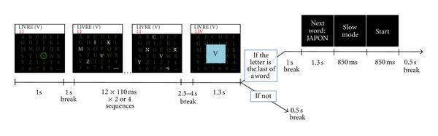

In each trial, the subject is asked to focus on a particular letter, so that **P300** occurred when that letter flashed. The spelling system would determine the letter through the subject’s brain wave. Then 2.5-4s after the flash period, the letter selected by the system would show up on the screen, which is called the feedback event. The dataset above contains two event types - one is **“FeedBack_correct"** and the other is **“FeedBack_wrong”**. The **“FeedBack_correct”** event means that the selected letter matches the subject's intention. Otherwise, the **“FeedBack_wrong”** event corresponds to the wrong letter selected by the system. Error-related potential occurs after the onset of the “FeedBack_wrong” event.

#### **EEG Dataset Preprocessing**

| **Problem 1** |
| --- |
| Please follow the following steps:   1. Plot 2D channel location map 2. Run ICA and record computational time of ICA by code. 3. Plot component maps in 2D. 4. Indicate noise component(s) if they exist and explain the reason why you identify this component as noise or artifacts. 5. Plot first 10-second channel data before and after deleting noise/artifact component(s). |

| **Problem 2** |
| --- |
| Please follow the following steps:   1. Plot 2D channel location map 2. **Bandpass filtering [1, 48]*Hz.*** 3. Run ICA and record computational time of ICA by code. 4. Plot component maps in 2D. 5. Indicate noise component(s) if they exist and explain the reason why you identify this component as noise or artifacts. 6. Plot first 10-second channel data before and after deleting noise/artifact component(s). 7. **Discuss the effect of bandpassing(highpassing) the signal before running ICA.** |

#### 

#### **Independent Component Analysis and Artifact Removal**

| **Problem 3**  According to [Hu et al](https://www.sciencedirect.com/science/article/pii/S105381190901297X#), SNR of an ERP waveform can be defined as below:  Since the error-related potential originates from the [**anterior cingulate cortex**](https://en.wikipedia.org/wiki/Anterior_cingulate_cortex)**(ACC)**, we focus on the **FCz** channel. |
| --- |
| 1. Apply all four following preprocessing flows before calculating ERP at FCz: 2. Without any operation 3. Bandpass the signal (1~48 Hz) 4. Run ICA and remove bad components(Hint: using ICLabels) 5. Bandpass the signal (1~48 Hz) first and run ICA to remove bad components 6. After the preprocessing, epoch the continuous EEG with a time interval [-0.2 1.3] sec, where t=0 is the feedback onset. (Hint: [EEGLAB epoch](https://eeglab.org/tutorials/07_Extract_epochs/Extracting_Data_Epochs.html)) 7. Remove the epoch baseline mean. 8. Plot the ERP at FCz time-locked to the two different events(i.e the correct and error feedbacks)   (Hint: In the MATLAB workspace, you can see an EEG structure that contains all the information of the current EEGLAB dataset. EEG.data is an array of shape (num_channel, num_sample, num_trial))  Example:     1. Fill out the table below  | **Preprocessing Methods** | **ERP plot for 2 types of feedback** | **SNR(error feedback only)** | | --- | --- | --- | | Without any operation |  |  | | Bandpass only |  |  | | IC removal only |  |  | | Bandpass+IC removal |  |  | |
|  |

#### 

### 

### **Bonus Problem**

#### Independent Component Analysis

* + 1. Motivation: Blind Source Separation

Blind Source Separation is a problem in which we try to separate a set of source signals from a set of mixed signals without the aid of or with little aid of information about the source signals or mixing process. In short, the objective of this problem is to recover the original components from mixtures of signals. Below is the visual example of blind source separation.

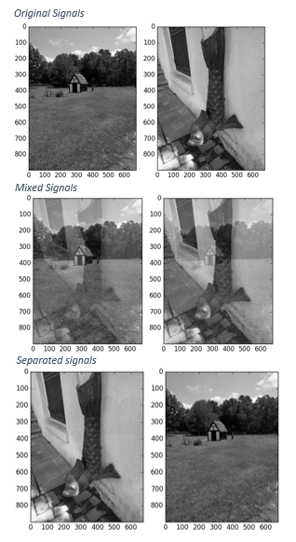

[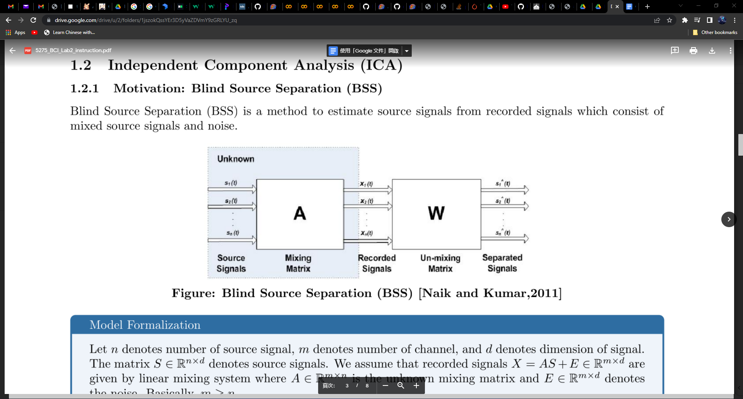](https://www.researchgate.net/publication/252066148_Dimensional_reduction_using_Blind_source_separation_for_identifying_sources)

The goal of BSS is to estimate and so that provides unknown source signals as possible.

* + 1. Cocktail Party Problem

One classic example of Blind Source Separation (BSS) is the Cocktail Party Problem, where people are talking simultaneously in a room and the listener/observer is trying to listen to one of the conversations. While humans can easily solve this problem, it is a hard problem in Digital Signal Processing

#### Let be a recorded signal and is a source signal according to the below formalization. We assume that is statistically independent.

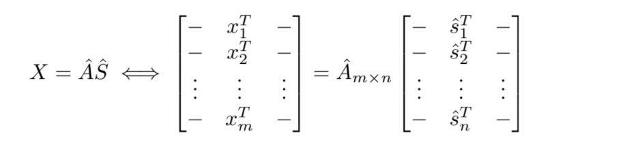

#### Independent Component Analysis is to estimate the independent component from.

### From now on we assume that *m = n* to simplify the model. Whitening is useful for PCA and simplifies ICA problems. If we denote whitening signal as

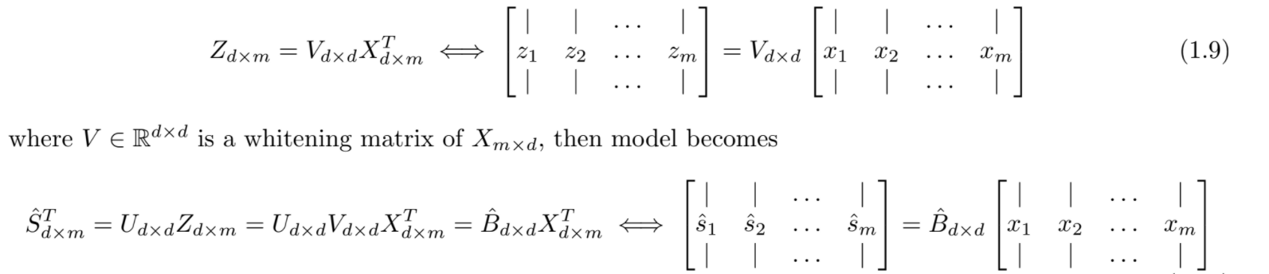

Where is a whitening matrix of ,, then model becomes



Where is an orthogonal transformation matrix.

**Hence it’s necessary to estimate U!**

The gaussianity of (sums of non-gaussian random variables) must be larger than S (original) according to Central Limit Theorem. Let be the observed signals, we want to maximize the non-gaussianity of source signals .

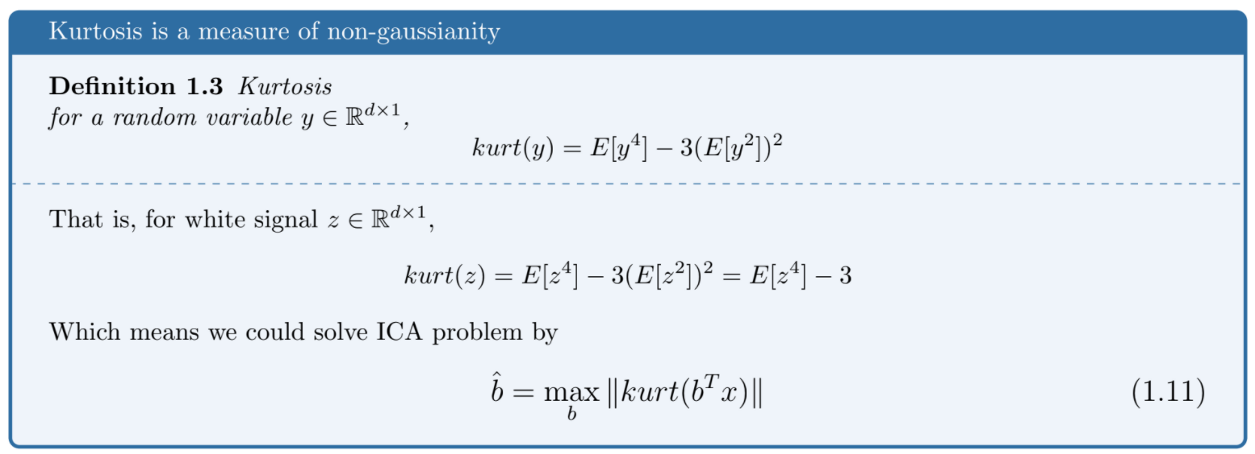

| **Bonus Problem : Solving ICA problem by kurtosis (z is white signal)** |
| --- |

### 

### **References**

L. Hu, A. Mouraux, Y. Hu, G.D. Iannetti, A novel approach for enhancing the signal-to-noise ratio and detecting automatically event-related potentials (ERPs) in single trials, NeuroImage, Volume 50, Issue 1,2010, Pages 99-111. ([link](https://www.sciencedirect.com/science/article/pii/S105381190901297X))

Perrin, M., Maby, E., Daligault, S., Bertrand, O., & Mattout, J. Objective and subjective evaluation of online error correction during P300-based spelling. Advances in Human-Computer Interaction, 2012, 4. ([link](http://www.hindawi.com/journals/ahci/2012/578295/))

Winkler I, Debener S, Müller KR, Tangermann M. On the influence of high-pass filtering on ICA-based artifact reduction in EEG-ERP. Annu Int Conf IEEE Eng Med Biol Soc. 2015;2015:4101-5. doi: 10.1109/EMBC.2015.7319296. PMID: 26737196 ([link](https://ieeexplore.ieee.org/stamp/stamp.jsp?arnumber=7319296))